
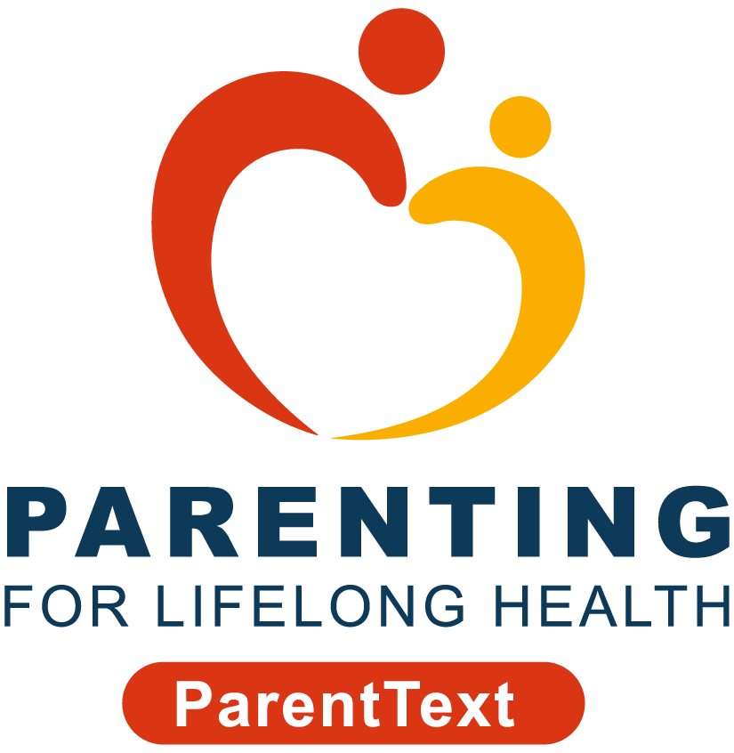



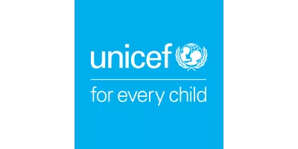

You’re invited to join a study carried out by researchers from the Universities of Cape Town and Fort Hare in South Africa and the University of Oxford in the United Kingdom.
We’re doing this study to learn about your experience with chatbots developed by Parenting for Lifelong Health (PLH), Clowns Without Borders South Africa (CWBSA), IDEMS International, and UNICEF South Africa.
Before you decide if you’d like to join, it’s important for you to know why we’re doing this research and what it involves. You can read through this Participant Information Sheet.
If you have any questions about the chatbot or if something isn’t clear, please email the study team at ParentText@globalparenting.org or call us at [insert South African cellphone number once available]. We’re here to help you!
Who can join?
To be part of the study, you need to be over 18 years or older, be the parent or caregiver of a child between the ages of 2 and 17 years, and live in South Africa. You also need to agree to take part in the study.
Do I have to join?
No, it's up to you if you want to join or not. If you don't want to participate, nothing bad will happen to you or your family. If you do choose to join but don't want to answer some questions, you can stop at any time. You can still get the chatbot messages even if you don't answer the questions. If you want to stop getting messages, you can type "STOP MESSAGES".
What happens if I join?
If you decide to join, you’ll need to read the consent form below and answer “Yes” on WhatsApp to the question, “I have read and understand the information, and I give consent to participate in the study”. Then, the study team will send you a survey through WhatsApp with about 30 questions. The survey asks about your life and one child you take care of. If you have more than one child, you’ll be asked to pick the child you find most challenging. We’ll send you a survey with questions again one month later and then again after three months. You’ll also be asked to do a phone interview with one of our researchers.
Please note that before you answer any questions or talk to someone from our team, make sure you're in a safe and private place. It could be your room or somewhere quiet where no one can listen in. This will help keep your information private and make sure you feel comfortable when you're answering questions.

After completing the first survey, you’ll get one of three types of messages:
- ParentText chatbot
- ParentText-PLUS chatbot
- WASHText chatbot
The ParentText chatbot is a 5-day course for parents and caregivers with 5 daily lessons on building a good relationship with your child.
The ParentText-PLUS chatbot has the same lessons plus an extra course on helping your child learn and develop. This extra course will be available one month after the first one to give you time to use the skills that you learned in the first course.
The WASHText chatbot is a 5-day course on keeping you and your children healthy, with 5 daily lessons on handwashing, hygiene, and health.
The type of chatbot messages you receive will be completely random. This means that an automatic lottery system will decide which group you are in.
Do I get anything for joining?
You’ll get R25 for finishing the first survey, R50 for the second survey, and R75 for the last one. If you’re chosen for a phone interview with someone from our team, you’ll get R100.
What happens to my information if I join?
We only collect what’s needed for the study and store it securely. Your information, including the answers you give during the surveys, will be kept safe on secure servers at the Universities of Oxford, Fort Hare, and Cape Town. Any details that identify you will be kept separate and only authorised staff can access them. All data will be kept for five years after the study, but personal information will be deleted when the study ends. Ethics committees and monitors may check the information. Your information will stay private unless the law says otherwise. After the study, we may share the information with other researchers but without your details. You have the right to see, correct, or ask us to delete your personal information.
What happens to the research results?
Your participation and what you tell us will help us understand how to support families like yours. We plan to share the results in journals, policy briefs and conferences so others can learn from this study too.
Who’s in the study team?
The principal investigators of this study are Dr Jamie Lachman (Universities of Oxford and Cape Town) and Dr Hlengiwe Gwebu (University of Fort Hare), and the Research Manager is Zamakhanya Makhanya (University of Cape Town).
Are there any risks in joining?
We don’t expect any risks to you if you join this study. If any questions make you uncomfortable, you don’t have to answer them. If you become upset when using the programme, you can type “HELP” to receive troubleshooting messages. Remember, you can stop participating anytime without giving a reason.
Who pays for the study?
This study is part of the Global Parenting Initiative, funded by the LEGO Foundation (CVR00940), Oak Foundation, the World Childhood Foundation (16191), The Human Safety Net, and the UK Research and Innovation Global Challenges Research Fund (ES/S008101/1).
Data protection
The Universities of Cape Town, Fort Hare and Oxford make sure your personal information is used safely and correctly, just for research. The study follows data protection laws like GDPR (General Data Protection Regulation) in the UK and POPIA (Protection of Personal Information Act) in South Africa. You can learn more about your rights regarding your data by following this link: https://compliance.admin.ox.ac.uk/individual-rights
Who has approved this study?
This study has received approval from the University of Cape Town’s Centre for Social Science Research Ethics Committee [insert reference number when available], the University of Oxford’s Social Sciences and Humanities Interdivisional Research Ethics Committee [insert reference number when available], and the University of Fort Hare’s Health Research Ethics Committee [insert reference number when available].
Who do I contact if I have questions or concerns?
If you have any questions or concerns about your rights as a study participant, you can contact the study team at ParentText@globalparenting.org or [insert South African cellphone number once available]. You can also reach the Research Officer, Zamakhanya Makhanya, at the University of Cape Town, Centre for Social Science Research at zamakhanya.makhanya@globalparenting.org.
If you have more questions or concerns about your rights, you can contact one of the ethics committees listed:

Name | Telephone | Email
University of Cape Town | +27 21 650 4656 | cssr@uct.ac.za
University of Oxford | +44 1865616578 | ethics@socsci.ox.ac.uk
University of Fort Hare | +27 043 704 7585 | aokeyo@ufh.ac.za

Informed Consent to Take Part in the Study

Please read these statements carefully:
- I have read the information above and know what I need to do.
- I had time to think about the information and ask questions. I got satisfying answers.
- I know I can say yes or no to being in the study. If I say yes, I can stop anytime before the 31st of December 2024, without saying why, and nothing bad will happen.
- I know who can see my information, how it will be kept safe, and what happens to it after the study.
- I know I won’t be named in any papers or reports from this study.
- I know who to tell if I have a problem with the study.
- You can contact me again if more information is needed from me.
- You can keep my contact information safe so you can tell me about the results of the study.
If you have read and understand the above document, agree with the messages and give consent to participate in the study, press “Yes” in WhatsApp. Type "EXIT" in WhatsApp if you do not want to participate.

